**Convoy Office Admin Tools**

**(COAT)**

**User Menu**

**使用說明**

**Table of Content目錄**

Introduction 介紹 3

Medical Claim Query醫療賠償查詢 4

Name Card Request名片申請 5-7

Stationery Form Request文具申請 8

Marketing Premium Request推廣禮品申請 9

Access Card Request員工證申請 10

ADM Service Request行政部之服務申請 11

Key Request鎖匙申請 12

Company Asset Request營銷物資申請 13-14

Room Setting Request合併會議室申請 15

Recruitment Advertising 招聘廣告申請………………………………………………………………………...……….16

IIQA Study Note Request 保險中介人素質保證計劃研習資料手冊申請…………………………………..17

**Introduction 介紹**

We are glad to announce the COAT Administration Platform Enhancement is ready for use. Those Function embedded in the “eConvoy > Tools > Office Admin”, in which you can check your Medical Claim history; place order of Name Card, Marketing Premium, Stationery, Access Card / Photo Sticker, Keys, requesting Company Asset & Room Setting and reporting Repair & Maintenance services in office area. Through this platform, AD / DD can also queue up for Recruitment Advertising.

行政部很高興通知大家，增強板COAT行政部管理平台已經可以使用。此功能設於“eConvoy > Tools > Office Admin”，在其中你可查詢過去醫療賠償紀錄，申請名片，文具，推廣禮品，員工證，行政部之服務，鎖匙，營銷物資及合併會議室之安排。AD/ DD更可透過此平台提交招聘廣告申請。

With COAT, your requests will be done electronically instead of filling physical forms. It serves your convenience and a Green office. The history of your requests can also be viewed in the COAT.

使用COAT， 你的所有申請將通過電子方式提交。除更方便外，減小用紙也能為環保出分力。你亦可以使用COAT查詢過去所有的申請紀錄。

Staff / Consultant may access through **(eConvoy 🡪 Tools 🡪 Office Admin)**

同事們可通過**(eConvoy 🡪 Tools 🡪 Office Admin)** 進入COAT

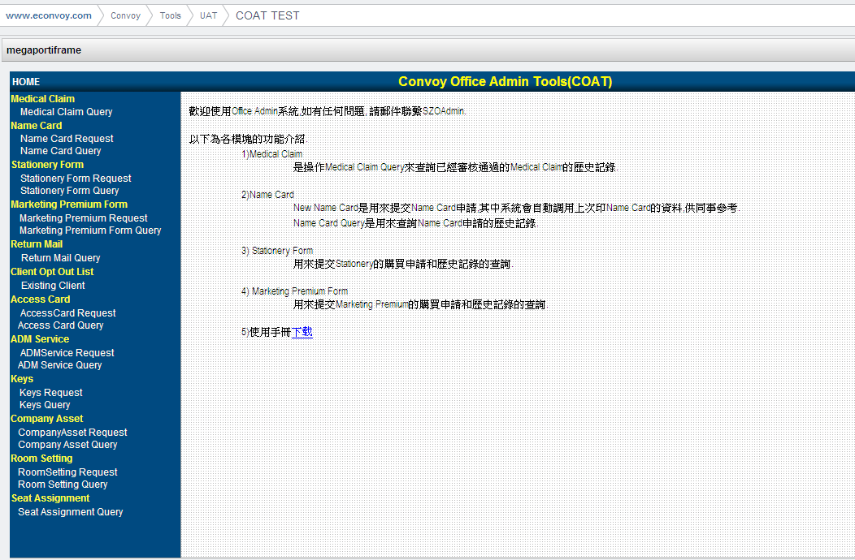

**Medical Claim 醫療賠償**

*For checking your medical claim history 查詢過往醫療賠償紀錄*

Medical Claim Query醫療賠償紀錄查詢

eConvoy 🡪 Tools 🡪 Office Admin🡪Medical Claim Query

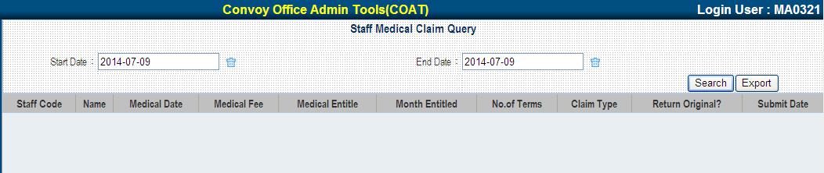

You may search by request period or even export an excel list to show all your reimbursement history.

你可根據申請期限查過去報銷紀錄及導出Excel列表。

**Name Card Request 名片申請**

*For request Name Card申請名片*

How to Apply 申請步驟

eConvoy 🡪 Tools 🡪 Office Admin🡪Name Card Request

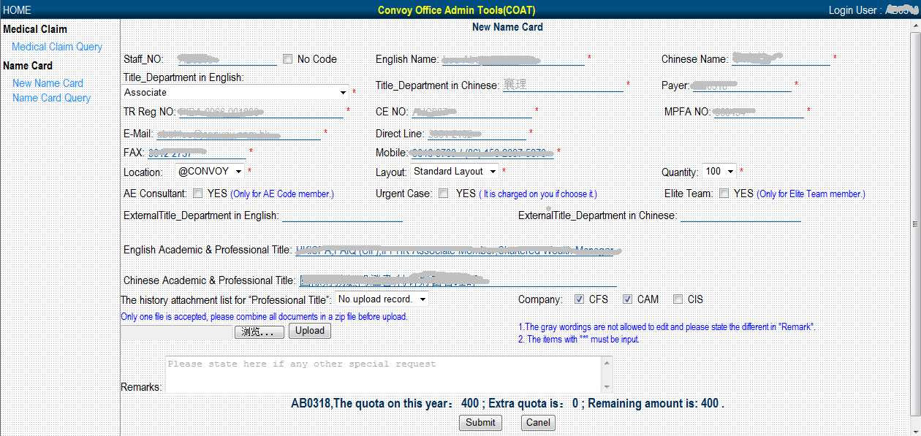

1. System will shows the corresponding personal information based on the login person

系統根據當前登錄的Staff Code 查詢出下列相應的個人信息

Staff No, English Name, Chinese Name, Payer, Title_Department In English, Title_Department In Chinese, TR Reg No, CE No, MPFA No, E-mail, Direct Line, Fax & Mobile phone based on the request history;

*No Code:

With position CWMA or above can apply name card for their new team member (who will report duty soon). If the new comer did not report duty before month end, that printing fee will be deducted from requestor’s commission.

職位在CWMA或以上的Consultant可以為未入職的新同事(即沒有staff code的新同事)申請辦理名片.如果在當月30號之前SZO Admin還未收到該同事的正式有效的staff code，則該筆名片費用將從申請人當月工資中扣除.

1. Quantity:

You may choose the print quantity from 100, 200, 300 & 400pcs.

在此選擇相應的名片印刷張數,選項包括:100,200,300,400四個

1. AE Consultant, Elite Team , Premium Layout:

System will check the qualification of requestor.

系統會根據Staff Code的當前信息進行判斷,如有資格,則可以進行選擇

1. Location:

Please choose the relevant location.

請選擇對應的辦公室所在位置

1. Urgent Case:

For Urgent Case, free Print Quota cannot be use. Printing fee will be deducted from requestor’s commission.

勾選Urgent Case後，系統將對當次申請進行正常收費，印刷數量不計入免費限額中.

1. External Title_Department in English, External Title_Department in Chinese:

Please fill here for external title and get CDD approval before apply.

如需印刷與當前職位不相符的名片時，請在此處填寫,在提交之前請務必提交CDD的相應的Email至SZOAdmin以供審批.

1. Academic & professional title:

Maximum input of 4 Professional titles and 1 Academic title.

For Professional title，certificate must be email to SZO Admin in PDF file.

最多只允許填寫四個professional title和一個Academic title.

在填寫Professional title後，必須上傳該professional title的證書附件（pdf類型）如有多個title的證書需要提供,請將其整理為一個PDF檔或壓縮為一個壓縮包後,再進行上傳。

1. Remark:

During the application, if any information incorrect and cannot be modify, please supplement in the REMARK

在填寫過程中，如果發現系統獲取的相關信息與本人信息不符而又無法修改時，請在Remark中進行補充.

Name Card Query 名片申請步驟

eConvoy 🡪 Tools 🡪 Office Admin🡪Name Card Query

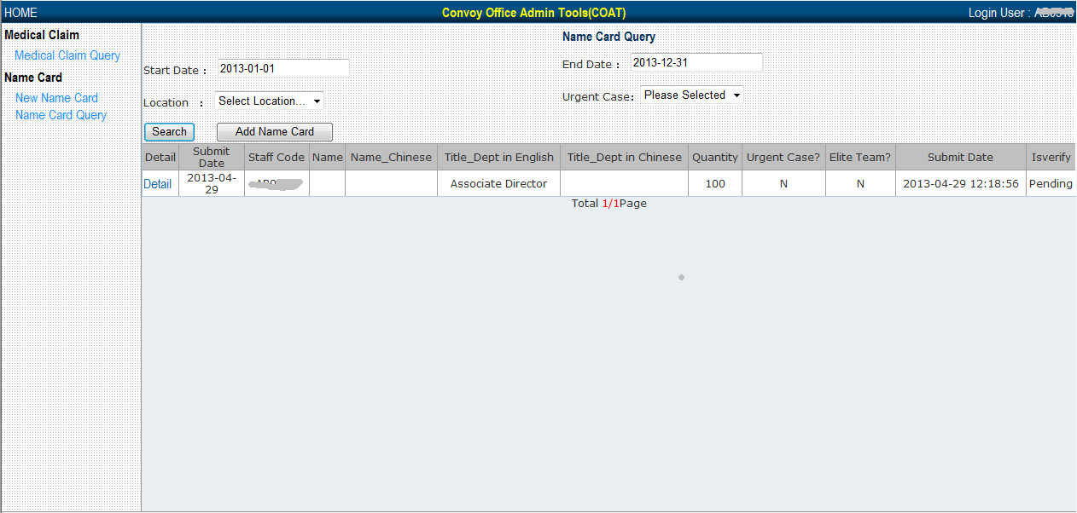

You may search by Request Date to show all your request history.

你可根據申請日期查詢過去申請紀錄。

**Stationery Form Request文具申請**

*For request / purchase stationery 申請 / 購買文具*

How to Apply申請步驟

eConvoy 🡪 Tools 🡪 Office Admin🡪Stationery Form Request

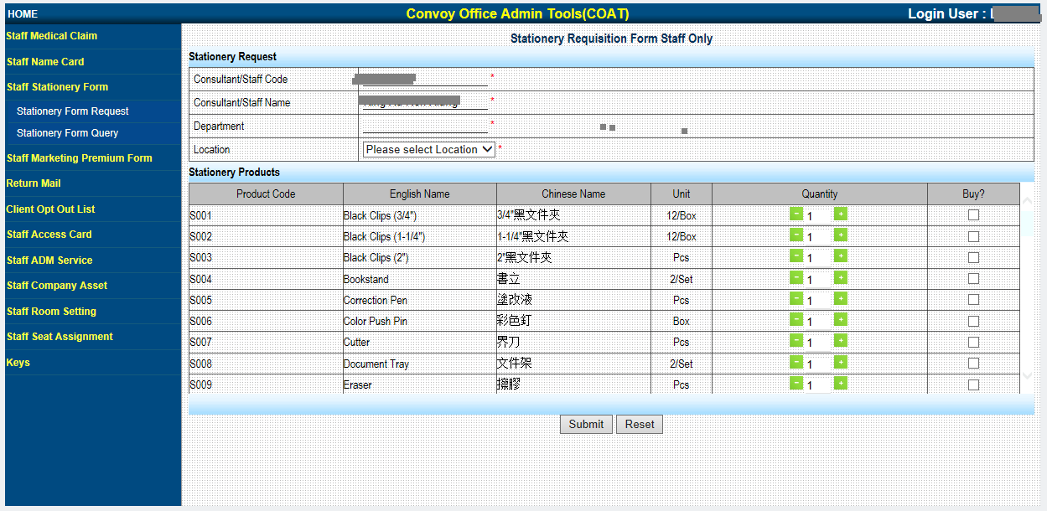

2. “Click” the “Buy?” box for the item your select.

勾選所需要購買的產品後面對應的 “Buy?複選框”。

3. Change the “Quantity”. 修改對應的購買數量 “Quantity”。

4. Sum of the Total Amount will be shown. 頁面上Total：表示本次購買所需支付的總金額。

5. Press Submit button. 點擊”Submit 按鈕”進行提交申請。

1. Staff code & Name are default according to your login, please choose location.

系統根據當前登錄者顯示Staff Code和名，請選擇對應的辦公室樓層。

Stationery Form Query文具申請查詢

eConvoy 🡪 Tools 🡪 Office Admin🡪Stationery Form Query

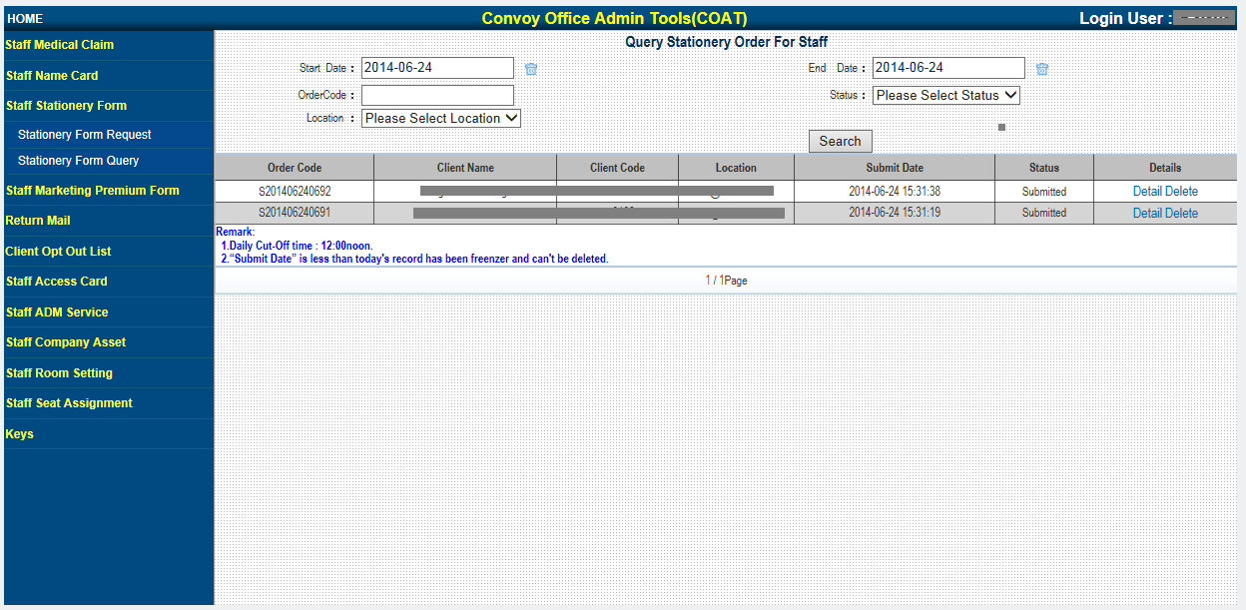

You may search by Request Date to show all your request history.

你可根據申請日期查詢過去申請紀錄。

**Marketing Premium Request推廣禮品申請**

*For request / purchase Marketing Premium申請 / 購買推廣禮品*

How to Apply申請步驟

eConvoy 🡪 Tools 🡪 Office Admin🡪Marketing Premium Request

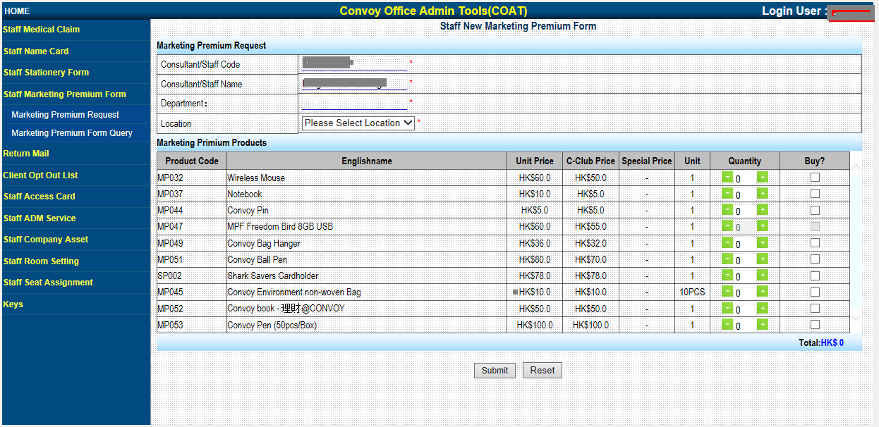

2. “Click” the “Buy?” box for the item your select.

勾選所需要購買的產品後面對應的 “Buy?複選框”。

3. Change the “Quantity”. 修改對應的購買數量 “Quantity”。

4. Sum of the Total Amount will be shown.

頁面上Total：表示本次購買所需支付的總金額。

5. Press Submit button. 點擊”Submit 按鈕”進行提交申請。

Staff code & Name are default according to your login, please choose location.

系統根據當前登錄者顯示Staff Code和名，請選擇對應的辦公室之樓層。

Marketing Premium Query推出禮品申請查詢

eConvoy 🡪 Tools 🡪 Office Admin🡪Marketing Premium Query

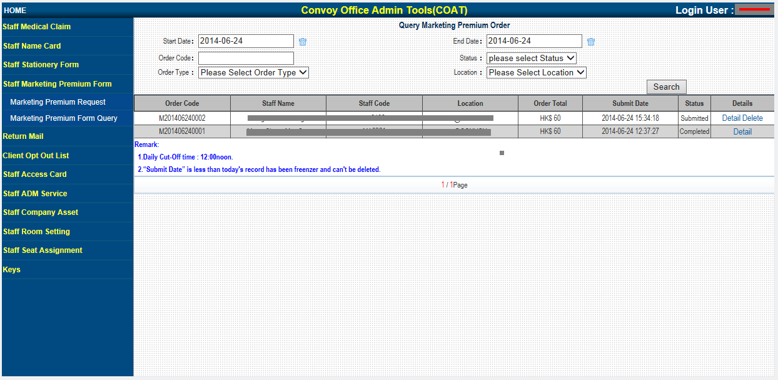

You may search by Request Date to show all your request history.

你可根據申請日期查詢過去申請紀錄

**Access Card Request員工證申請**

*For loss or request to replace access card and photo sticker補辦員工證*

How to Apply申請步驟

eConvoy 🡪 Tools 🡪 Office Admin🡪Access Card Request

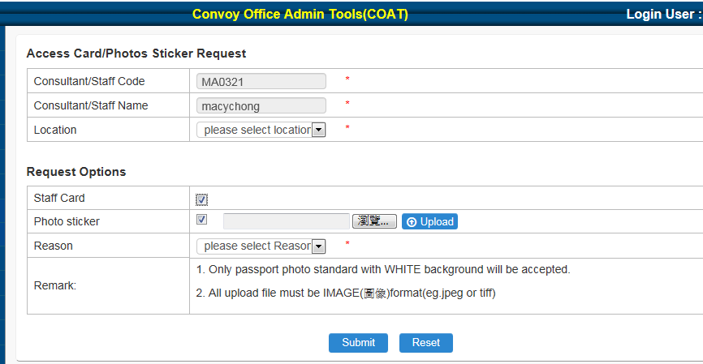

1. Staff code & Name are default according to your login, please choose location.

系統根據當前登錄者顯示Staff Code和名，請選擇對應的辦公室之樓層。

2. Select the item you need and choose a reason. 選擇申請項目及補領原因。

3. For Photo Sticker request, you may upload a recent photo. 在申請員工證時，你可上傳一張近照。

4. Press the submit button. 點擊”Submit 按鈕”進行提交申請。

Access Card Query員工證申請查詢

eConvoy 🡪 Tools 🡪 Office Admin🡪Access Card Query

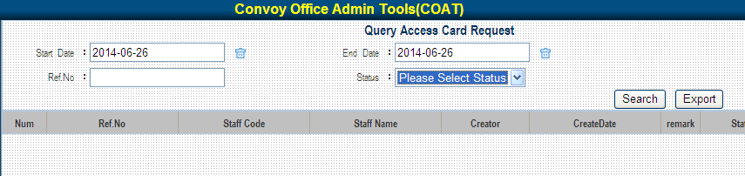

You may search by Request Date, Ref No., Status or even export an excel list to show all your request history. 你可根據申請日期，Ref No.或狀態查詢過去申請紀錄及導出Excel列表。

**ADM Service Request行政部之服務申請**

*For reporting repair & maintenance services in office area and Phone problems. 申報辦公室內的所有維修事宜及電話系統問題*

How to Apply申請步驟

eConvoy 🡪 Tools 🡪 Office Admin🡪ADM Service Request

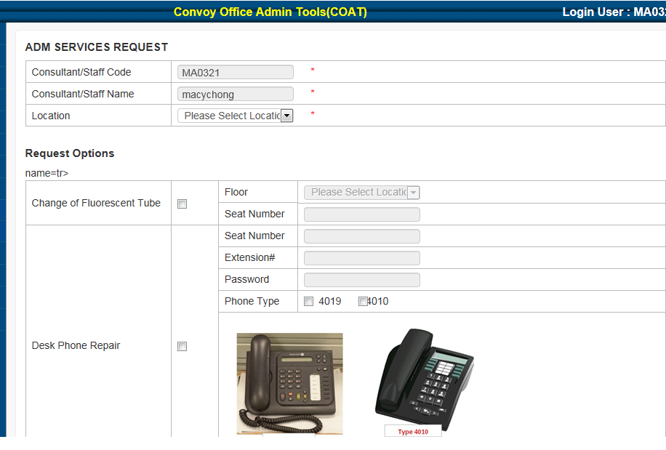

2. Select the item you need to report. 選擇申請項目。

3. Press submit button. 點擊”Submit 按鈕”進行提交申請。

1. Staff code & Name are default according to your login, please choose location only.

系統根據當前登錄者顯示Staff Code和名，請選擇對應的辦公室之樓層。

ADM Service Query 行政部之服務申請查詢

eConvoy 🡪 Tools 🡪 Office Admin🡪ADM Service Query

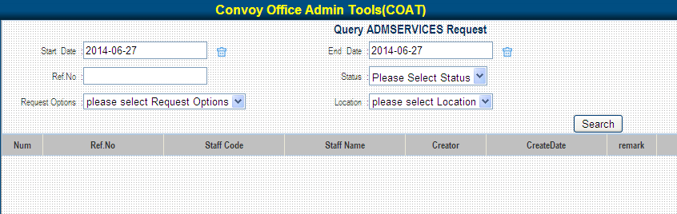

You may search by Request Date, Ref No., Request Options or Status to show all your request history. 你可根據申請日期，Ref No., 申請項目或狀態查詢過去申請紀錄。

**Keys Request鎖匙申請**

*For request replacement of locker, desk drawer & pigeon box key*

*補領 儲物櫃，枱底中置櫃桶及郵箱鎖匙*

*Due to the security reason, requestor only allows to apply the keys of their official assigned seat.*

How to Apply申請步驟

eConvoy 🡪 Tools 🡪 Office Admin🡪Keys Request

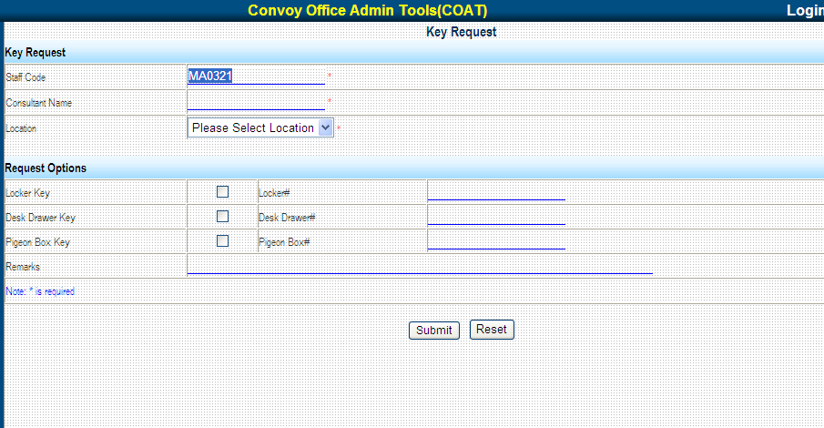

1. Staff code & Name are default according to your login, please choose location.

系統根據當前登錄者顯示Staff Code和名，請選擇對應的辦公室之樓層。

1. Select the key you needed. 選擇申請的鎖匙類別。
2. Press the Submit button. 點擊”Submit 按鈕”進行提交申請。

Keys Query鎖匙申請查詢

eConvoy 🡪 Tools 🡪 Office Admin🡪Keys Query

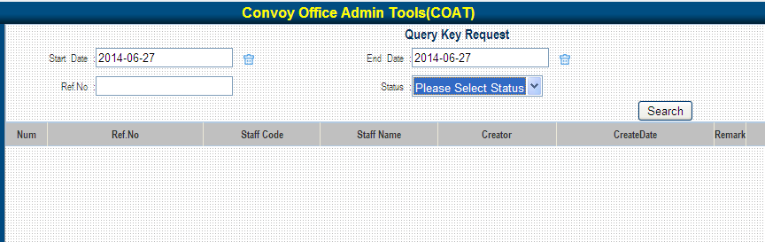

You may search by Request Date, Ref No. or Status to show all your request history.

你可根據申請日期，Ref No.或狀態查詢過去申請紀錄。

**Company Asset Request營銷物資申請**

*For Company Asset (Banner, 易拉架, Sales Booth, etc…) borrow*

*申請營銷物資(橫額, 易拉架, 銷售展台, 等物品…)外借服務*

How to Apply申請步驟

eConvoy 🡪 Tools 🡪 Office Admin🡪Company Asset Request

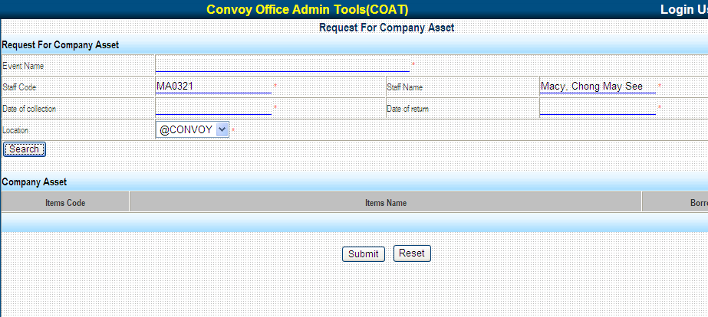

1. Fill in the Event Name, Date of Collection & Date of Return.

輸入活動名稱, 取貨及歸還日期。

1. Press the Search button. 點擊”Search 按鈕”，系統將列出可借物品清單。

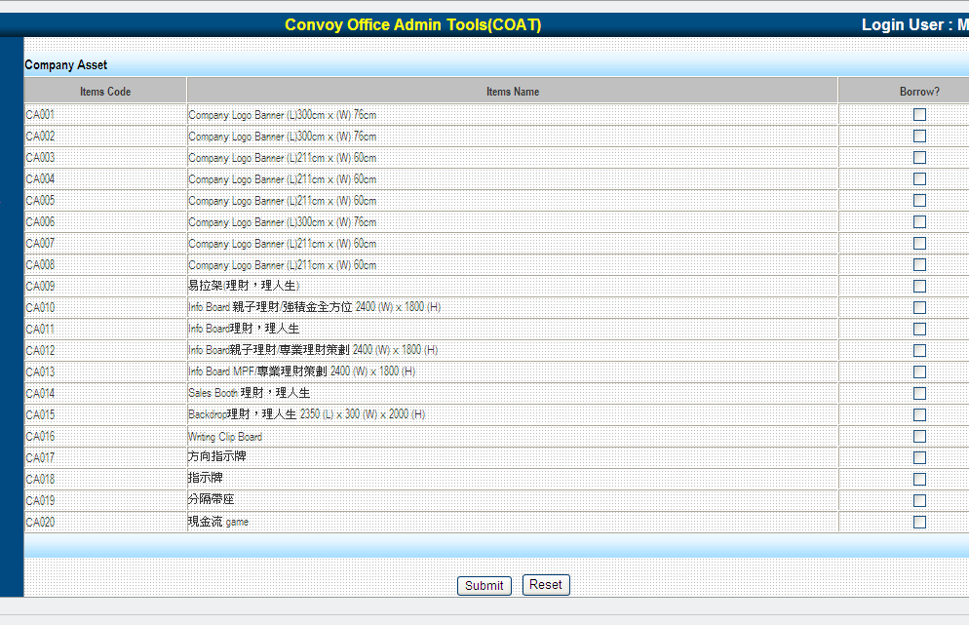

3. Click the “Borrow?” box for the item your select.

勾選所需要物品後面對應的 “Borrow?複選框”。

1. Press the Submit button. 點擊”Submit 按鈕”進行提交申請。

Company Asset Query營銷物資申請查詢

eConvoy 🡪 Tools 🡪 Office Admin🡪Company Asset Query

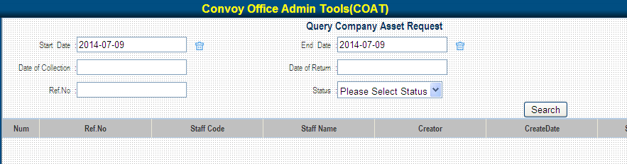

You may search by Request Date, Date of Collection or Date of Return to show all your request history. 你可根據申請日期, 取貨日或歸還日查詢過去申請紀錄。

**Room Setting Request合併會議室申請**

*For combine room at 5/F @CONVOY & 17/F City Plaza 3*

*申請合併5/F@CONVOY及 17/F CP3的會議室*

How to Apply申請步驟

eConvoy 🡪 Tools 🡪 Office Admin🡪Room Setting Request

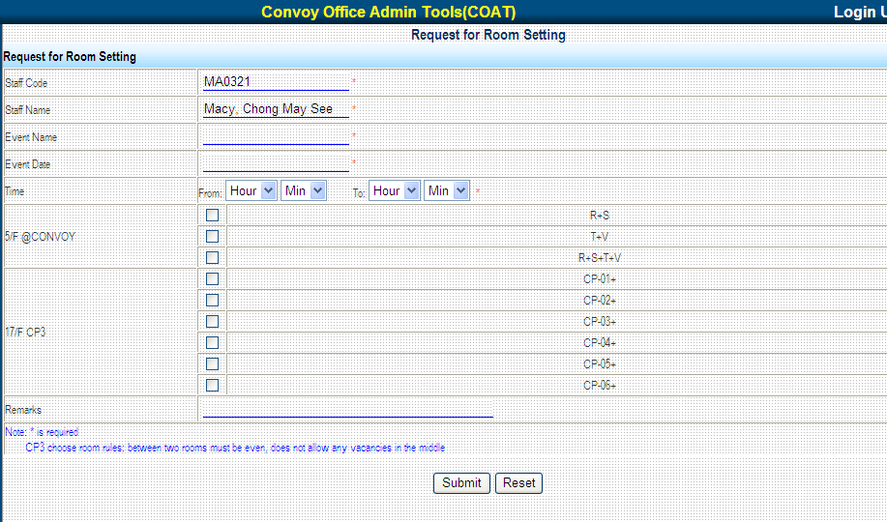

1. Fill in the Event Name, Event Date & Time. 輸入會議名稱,舉行日期及時候。
2. Select the request combine room number. 選擇需合併的會議室房號。
3. Press the Submit button. 點擊”Submit 按鈕”進行提交申請。

Room Setting Query合併會議室申請查詢

eConvoy 🡪 Tools 🡪 Office Admin🡪Room Setting Query

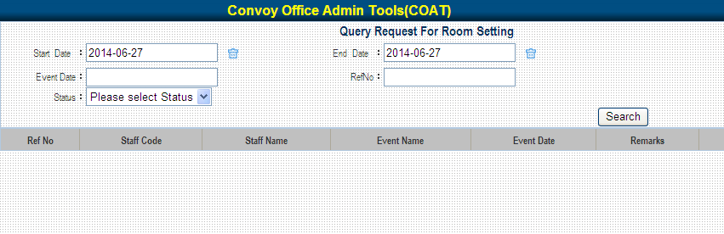

You may search by Request Date, Ref No., Event Date, Status to show all your request history.

你可根據申請日期, Ref No., 舉行日期或狀態查詢過去申請紀錄。

**Recruitment Advertising Request 招聘廣告申請**

*For request recruitment advertising placement (for AD and DD only)*

*申請刊登招聘廣告 (只限AD及DD申請)*

How to Apply申請步驟

eConvoy 🡪 Tools 🡪 Office Admin🡪Recruitment Advertising Request

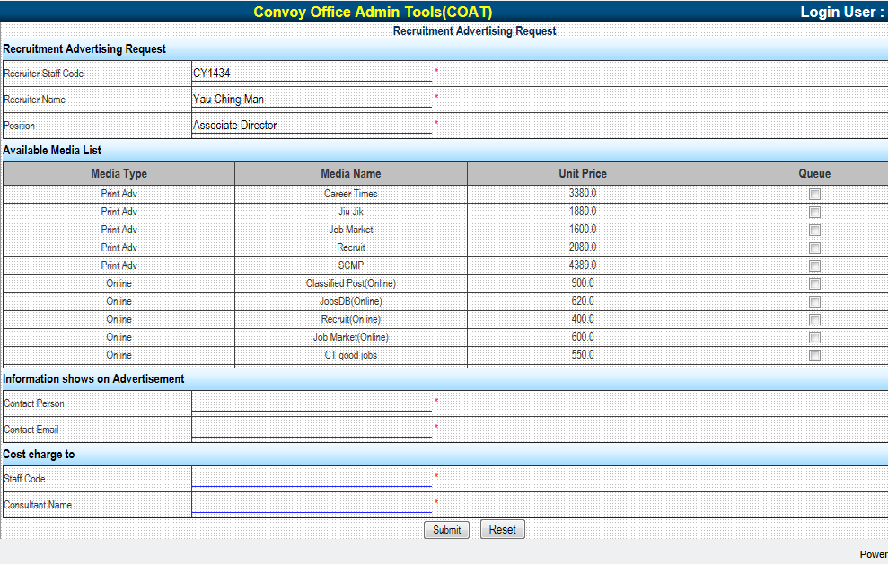

1. Fill in the Recruiter Staff Code (must be AD /DD). 輸入申請人Staff Code (必須是AD / DD)。
2. Click the “Queue” box for the Media your select. 勾選所選擇的傳媒後面對應的 “Queue”選框。
3. Fill in the contact information shows on advertisement. 輸入廣告中需刊登的聯絡人資料。
4. Fill in the staff code of the payer. 輸入付款人Staff Code。
5. Press the Submit button. 點擊”Submit 按鈕”進行提交申請。

Recruitment Advertising Query招聘廣告申請查詢

eConvoy 🡪 Tools 🡪 Office Admin🡪Recruitment Advertising Query

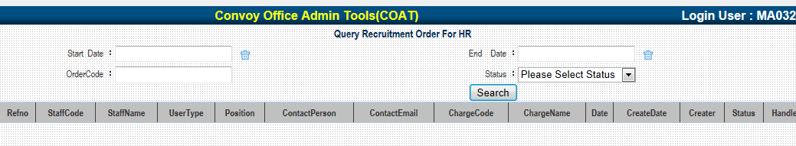

You may search by Request Date, Order Code, Status to show all your request history.

你可根據申請日期, Order Code或狀態查詢過去申請紀錄。

**IIQA Study Note Request**

**保險中介人素質保證計劃研習資料手冊申請**

*For Consultant & PA only只限顧問及PA申請*

How to Apply申請步驟

eConvoy 🡪 Tools 🡪 Office Admin🡪IIQAS Study Note Request

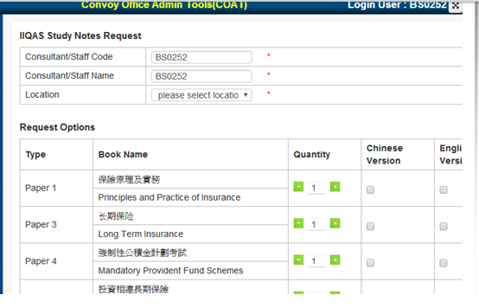

2. Select the item, quantity & version you need. 選擇申請項目, 數量及版本。

3. Input details of user (Full Name & Staff Code) 輸入使用者資料 (名 和 員工編號)

4. Press submit button. 點擊”Submit 按鈕”進行提交申請。

1. Staff code & Name are default according to your login, please choose location only.

系統根據當前登錄者顯示Staff Code和名，請選擇對應的辦公室之樓層。